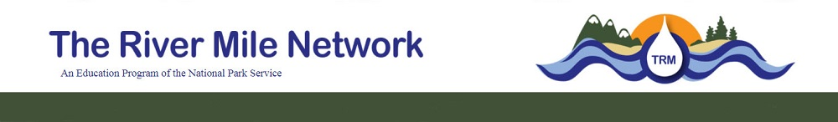

TRM Crayfish Study Short Form 2021
This form is designed for observations with or without set traps, but an in-depth study.

Group Information
Date of Submission:
Time of Submission:
Site Identification
Please provide the unique site identification for the area of collection. This is not the same as the data point. For example: Spring Canyon Day Use Area. This is not the specific location/data point of where you collected each specimen.

Collector Identification
Students, please use your teacher's last name.
Adults, please use your first and last name.

School/Organization

Group Grade Level
- Kindergarten
- 1st Grade
- 2nd
- 3rd
- 4th
- 5th
- 6th
- 7th
- Other
What is your role with the group?
- 8th
- 9th
- 10th
- 11th
- 12th
- College
- Adult

- Teacher/Leader
- Assistant/Chaperone
- Student (K-12)
- Participant (adult)
- Other

Specimen Information

Location of Specimen Collection: Latitude

Location of Specimen Collection: Longitude

Collection Date Collection Time
What method of data collection was used?
- Trap
- Net
- Caught by Hand
- Found (dead)
- Unknown
- Other

Crayfish Species
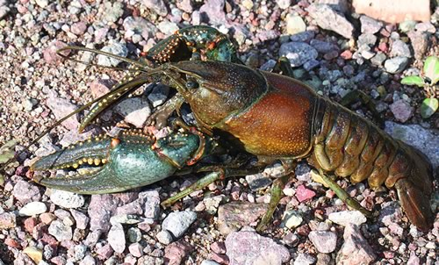
- Northern Crayfish (Orconecte Virilis)

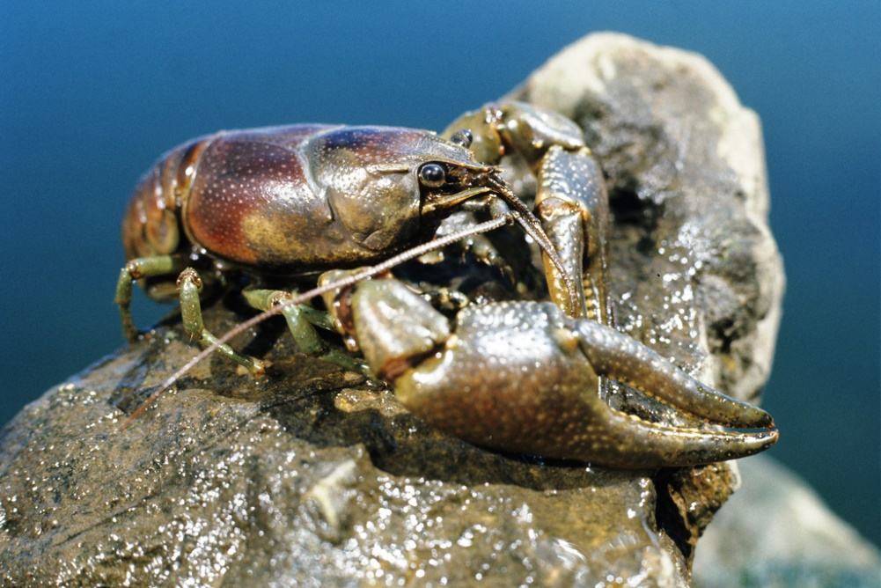
- Rusty Crayfish (Orconecte rusticus)
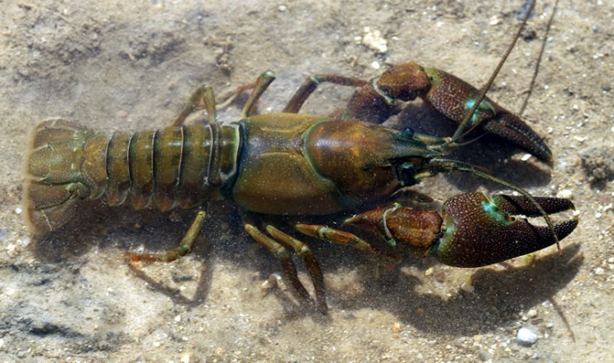
- Signal Crayfish (Pacifastacus leniusculus)

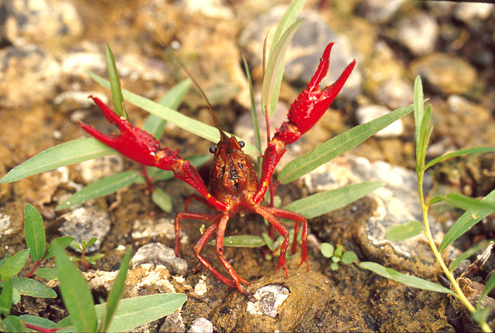
- Red Swam Crayfish (Proambarus clarkia)

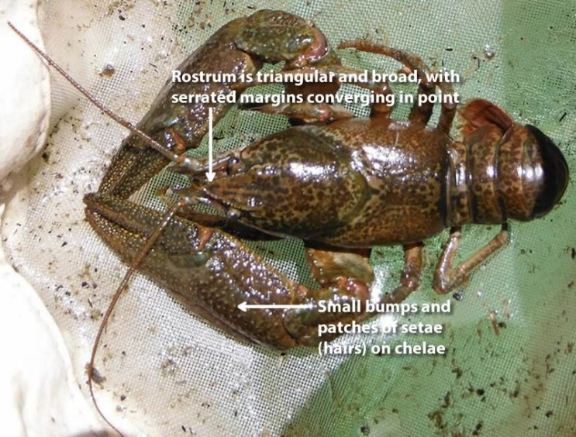
- Pilos Crayfish (Pacifastacus gambelii)
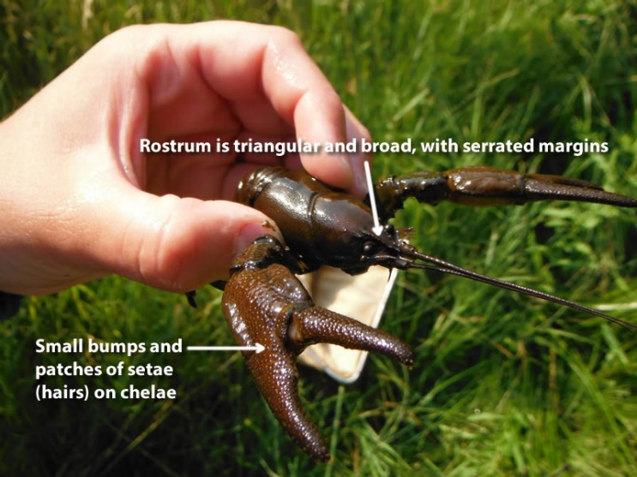
- Snake River Pilose (Pacifastacus Connectens)

- Unknown please provide a photo

- Other Species: please provide the species common and scientific

Uploading a photo? (Required if you are not sure of species)
Yes No

Photo name(s)

Optional Information
Sex
Alive, Dead or partial remains
- Alive
- Dead
- Partial Remains (pieces)
- Female
- Male
- Don’t know

Carapace Lenghth (in centimeters)
Total Length (in centimeters)
Name/Id of Data Entry Person

