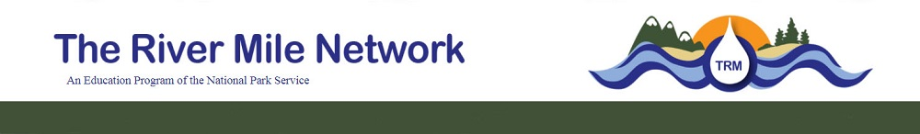

TRM Crayfish Study Long Form 2021
This is data collection form for The River Mile's Crayfish Study is for those participating in the full study. It can be used with any method of data collection.

You do not have to report all data. Location and species are required. If you do not know the species, please submit a photo and we will identify for you.
Required Identification Information
Date of Submission:
Time of Submission:
Site Identification
Please provide the unique site identification for the area of collection. For example: Spring Canyon Day Use Area.

This is not the specific location/data point of where you collected each specimen.

Collector Identification
Students, please use your teacher's last name.
Adults, please use your first and last name.

School/Organization

Group Grade Level
- Kindergarten
- 1st Grade
- 2nd
- 3rd
- 4th
- 5th
- 6th
- 7th
- Other
What is your role with the group?
- 8th
- 9th
- 10th
- 11th
- 12th
- College
- Adult

- Teacher/Leader
- Assistant/Chaperone
- Student (K-12)
- Participant (adult)
- Other

Core Parameters
Collection Date
Collection Time
Water Temperature (in Celcius)
Specific Conductivity (inuS)
pH
Dissolved Oxygen (in mg/L)
Air Temperature (in Celcius)
Wind Speed (in mph)
Wind Direction
- South-Southwest
- Southwest
- West-Southwest
- West
- West-Northwest
- Northwest
- North-Northwest

- North
- North-North East
- Northeast
- East-Northeast
- East
- East-Southeast
- Southeast
- South

Precipitation on Set Date?
Precipitation on Pull Date?
Bank Substrate
- Mud (silt/clay)
- Sand (particle diameter 0.06-2mm)
- Granule (particle diameter 2-4mm)
- Pebble (particle diameter 4-6.4mm)
- Cobble (particle diameter 6.4mm-25.6cm)
- Boulder (particle diameter particle diameter >25.6cm)
- Sheer Cliff
- Other

Bank Conditions
- Muddy
- Sandy
- Rocky
- Vegetated
- Other

Data Collection Method
What day and time did you set the trap?
Date Time
What day and time did you pull the trap?
Date Time
What method of data collection was used?
- Trap
- Net
- Caught by Hand
- Found (dead)
- Unknown
- Other

Collection Depth (in meters)

Crayfish Species
- Pilos Crayfish (Pacifastacus gambelii)

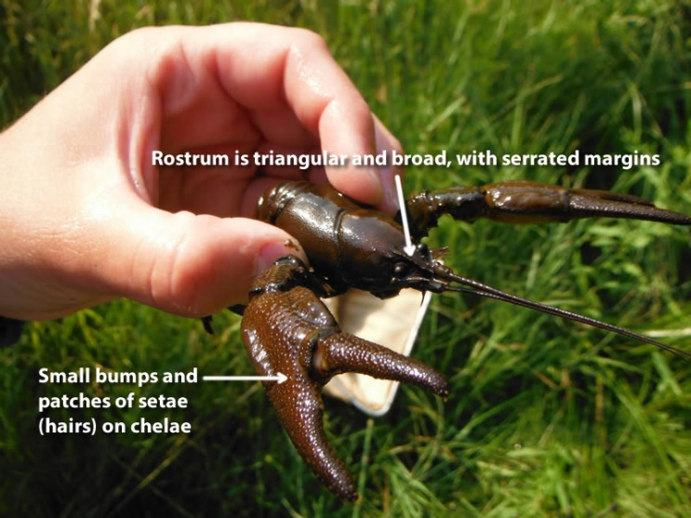

- Snake River Pilose (Pacifastacus Connectens) 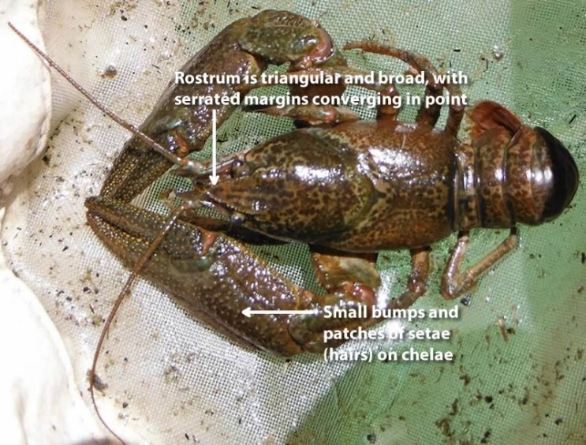

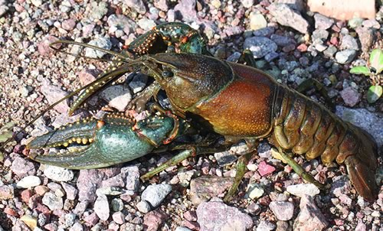
- Northern Crayfish (Orconecte Virilis)
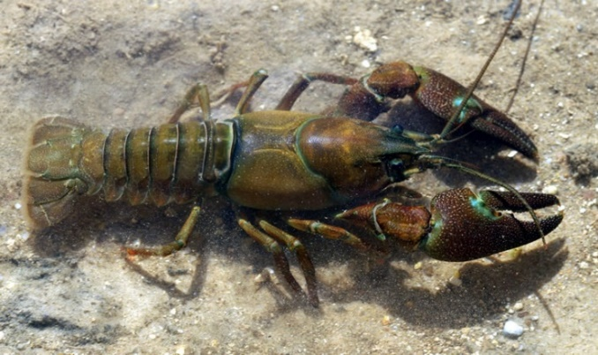
- Rusty Crayfish (Orconecte rusticus)

- Unknown please provide a photo

- Other Species: please provide the species common and scientific name
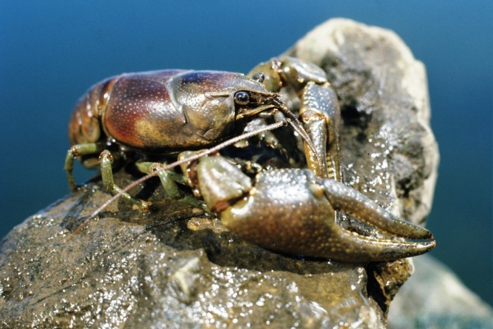
- Signal Crayfish (Pacifastacus leniusculus)

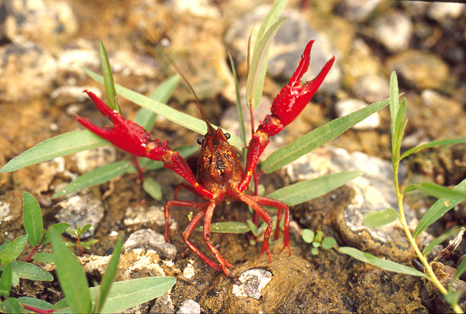
- Red Swam Crayfish (Proambarus clarkia)
Alive, Dead or partial remains
- Alive
- Dead
- Partial Remains (pieces)
Uploading a photo? (Required if you are not sure of species)
Yes No

Photo name(s)

Sex
Carapace Lenghth (in centimeters)
Total Length (in centimeters)

- Female
- Male
- Don’t know

Weight

Name/Id of Data Entry Person

