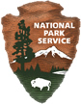
The River Mile
National Park Service
U.S. Department of the Interior

Lake Roosevelt
National Recreation Area
Lake Roosevelt

Natural Systems
Science Journal
By

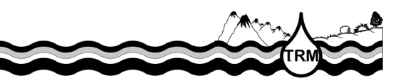

Observations Organizer
Writing Frame
Think about properties you can see such as size, shape, color, lines, texture, pattern, behavior | I observed……
Think of the other senses of smell, sound, touch and perhaps taste! | I noticed…..
Connect it with something you already know. | It reminds me of….
Add more detail as needed. | This is so because….
Be curious and ask questions you could investigate | I am curious about…..  It surprised me that……  I wonder what would happen if….
2000 © Betsy Rupp Fulwiler
Notes
What are the parts of the system you are observing?

- Identify inputs and outputs in your system. Where do the different parts get their energy and what do they give off?
System Part | Inputs | Outputs

- What are the functions of some of your systems’ parts?

- What are the subsystems?

- What would happen if one of the parts died or disappeared?

- What is the source of energy in your system? Is there only one source?

- What are 4 things your system needs to survive?
1
2
3
4

- What bigger system is your system a part of?
Draw and Label the system you are observing

The Name of my system is……..

I am curious about…..
System Questions to Consider
- What are the parts of the local system?
- What role/function do the plants in the system play?
- Identify one transfer or transformation of energy in the system.
- What are some inputs and outputs to the local system?
- What is the energy source that runs the local system?
- Name 2 subsystems within the local system.
- What might happen if the died?
- Is the local system an open or closed system? Why?
- Describe interactions between plants and animals in the system. Between living and non-living components.
- What role do humans play in your system?

