The River Mile
Crayfish Trap Construction

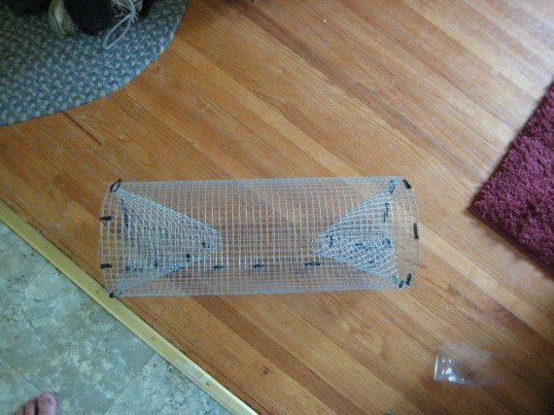
Gather Materials
A piece of hardware cloth 2’x20”. The rolls are 2’ wide.
1 door piece
1 circular pieces (cut in half)
20+- zip ties
1 foot of 16 gauge wire
Pliers
Wire cutters
Work gloves

Construction
Main Tube
- Cut a piece of hardware cloth 2’x20” for the main part of the trap
- Fold over the first 2-3 grid rows along the raw cut edge(s) to prevent you from getting stuck by the sharp wire edges.
- Roll into a cylinder shape with the 2 folded edges overlapping each other.
- Hold together using your zip ties and wire
End Pieces
- Carefully fold over the semi-circular pieces so the straight edges meet each other making a funnel shape. Connect these edges with wire or zip ties.
- Cut off the pointed end to make a hole about 2” in diameter
- Insert the funnel into the cylinder and fasten. Repeat for the other end.
Door
- Choose a location on the side of the cylinder to make a door. Count off a rectangle 4”x5”. You may either cut out completely or cut a criss cross pattern and fold pieces inward and secure. If you cut out completely, use duct tape to cover the edges.
- Now lay the door piece over the opening, overlapping it by about ½” and using your zip ties or wire create 2 hinges. Use your natural fiber rope to tie the door closed.
Final
- Tidy up loose ends and pieces of wire with your wire cutters.
National Park Service
U.S. Department of the Interior

Lake Roosevelt
National Recreation Area
Lake Roosevelt

